Introduction:

This is a web system for students grades , designed by three software experts . This system use some algorithms to modify the original grades , allowing customers to fulfill requirements .

Product Description:

This system includes the following function . First , there is an user interface containing two input bars . For security issue , the system will examine the correctness of the information typed by users , then turning logging page to main page . Second , because students and authorities have numerous subject to select , in the main page , we design a subject list in the form of scroll menu to deal with the problems . Third , it can calculate average score and standard deviation of each exam . Fourth , upon pressing the certain button , the system will show up grading trend of selected student in current course . Fifth , it also can demonstrate the distribution of the test grades in the form of chart . Sixth , when student who is on the edge of failing , the system will give warning messages to that student and the teacher . Seventh , Students who desire to know each grading component will be indicated by the information the teachers present . Eighth , in the case of the user who might be confused of how to use the system , they can access the FAQ service by pressing the button in the web page . Nineth , the database will store the information ( grades , logging account and password , courses ) of the students .

1. Calculation of average scores:

Input: initial scores

Output: average scores

1. Demonstration of scores trend (single student):

Input: database of scores

Output: graph

1. distribution(class student):

input: database of scores

output: bar chart

1. Notification of failing grades:

Input: students grades or database of scores

Output: grades under limitation and alarming messages

1. Class grading information of each test:

Input: database of courses

Output: information

1. Logging interface:

Input: user passwords and accounts and submit

Output: logging or denying

1. Subject list:

Input: database of courses

Output: a list of subject

1. Online User’s Manual(FAQ):

Input: user’s question

Output: the answers

1. Revised grades(gaussian):

Input: database of grades

Output: final grades

DFD:

Level0: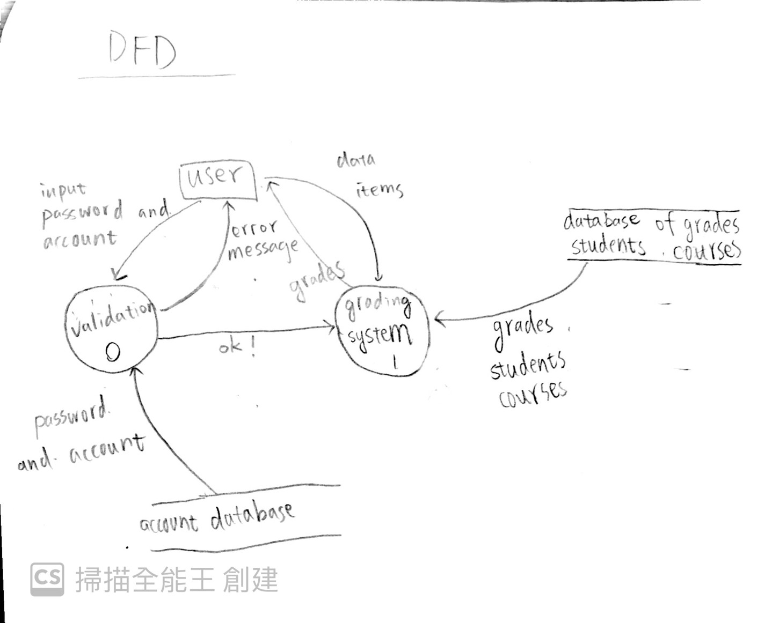

Level1: 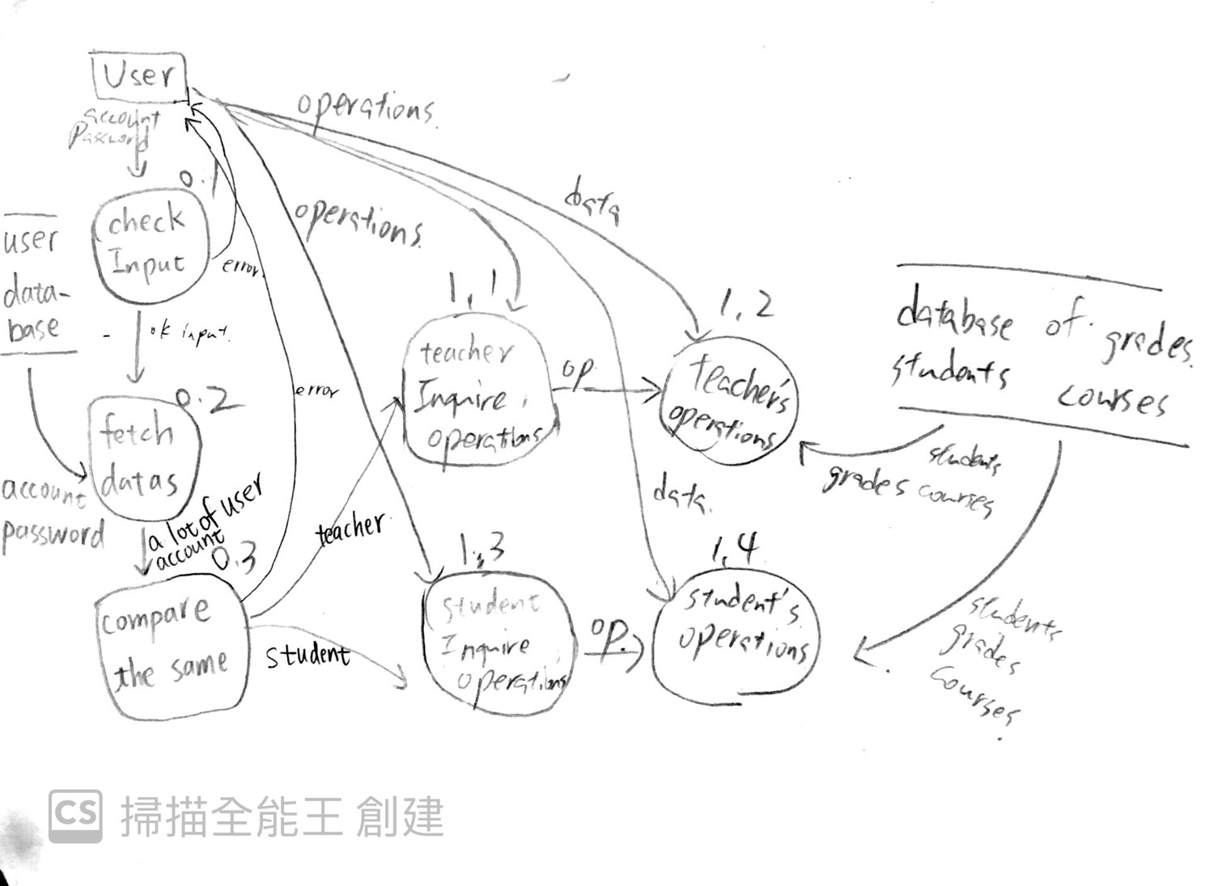

Level2:

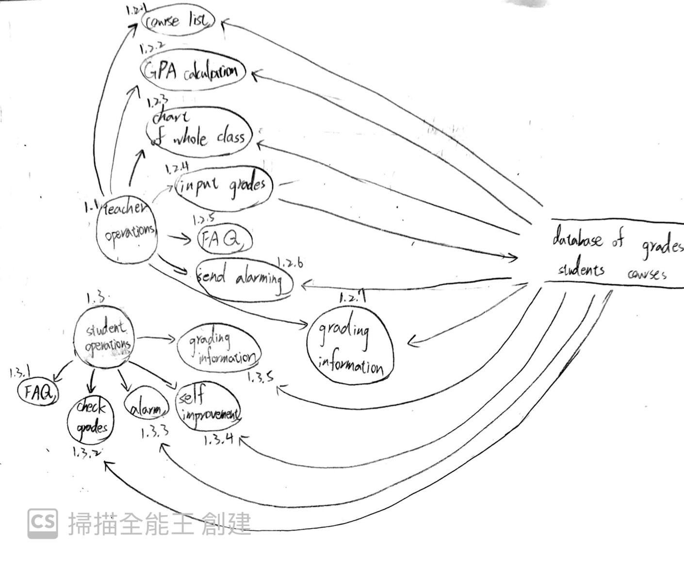

User-case diagram:

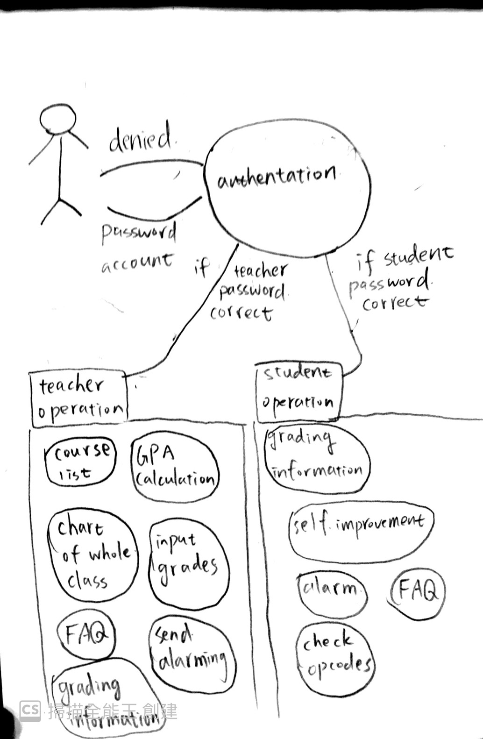

GUI: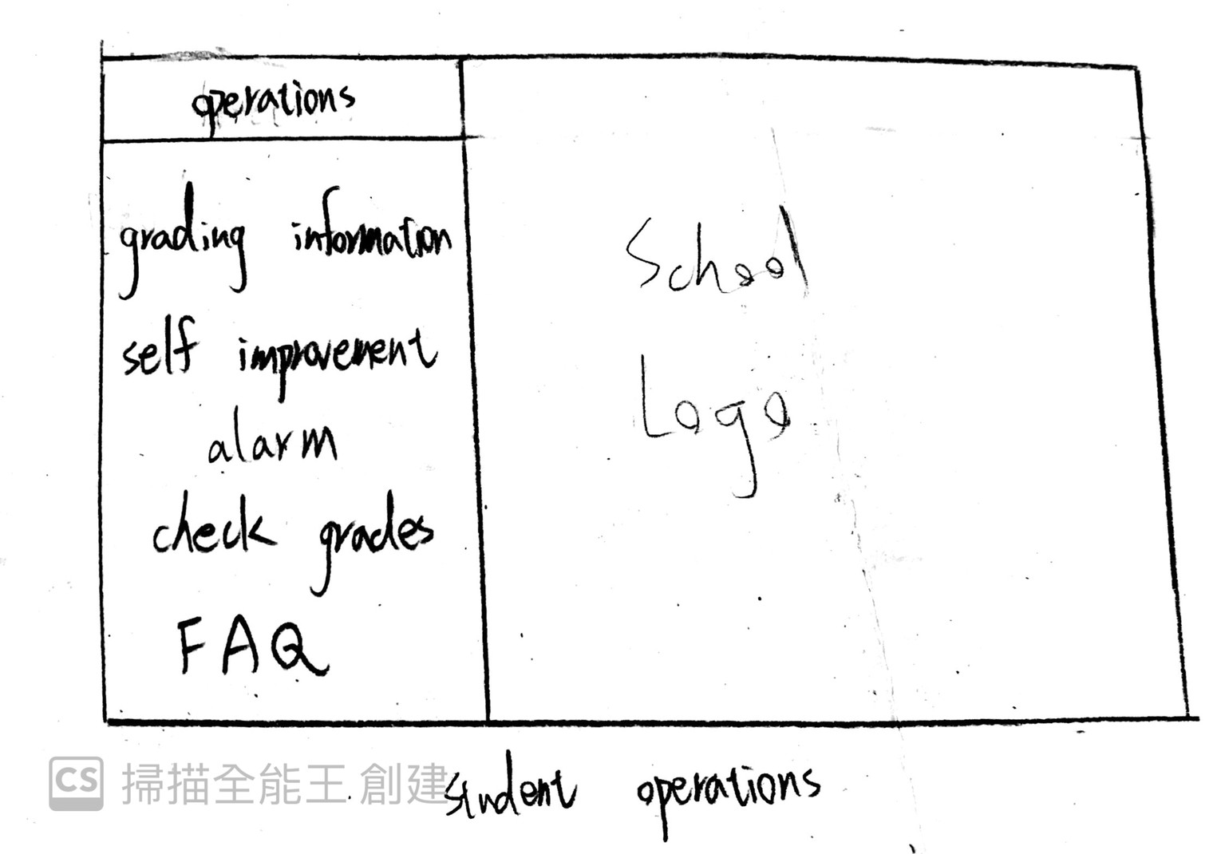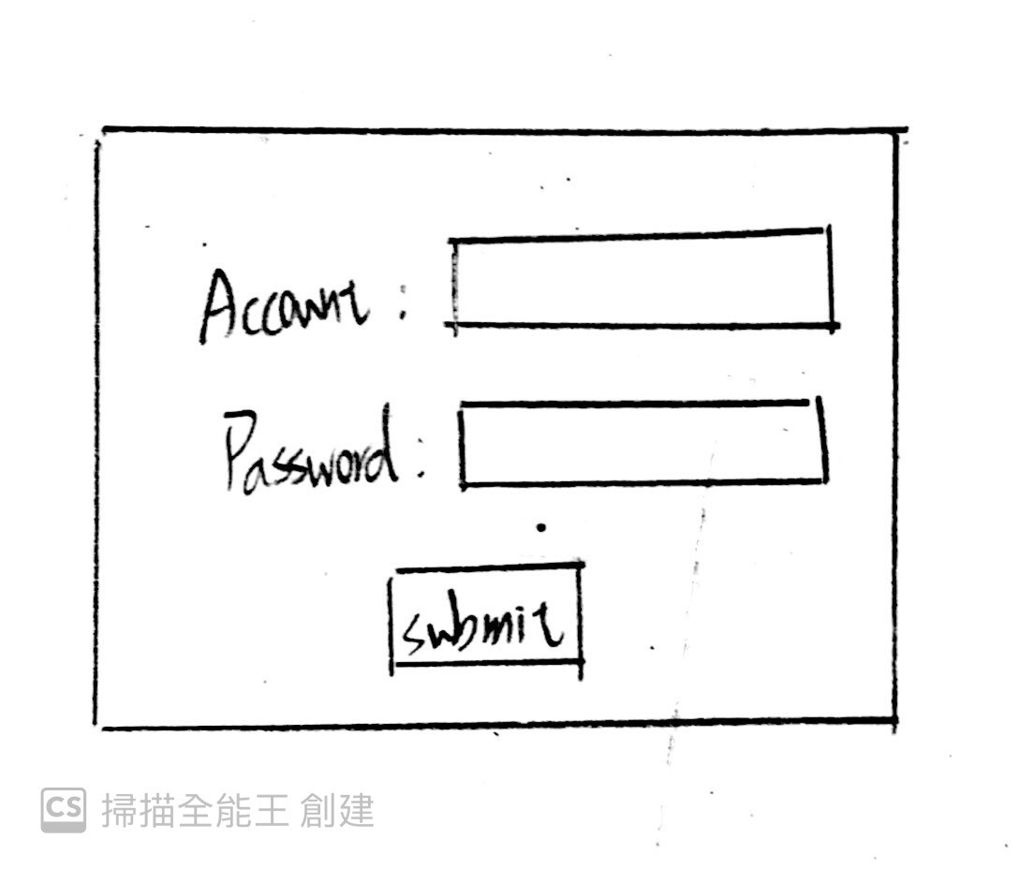



Nonfunction:

This website can support utmost 300 users to access to the web . The response time of web server should less than 10 msec . This software has simple and clean user interface . This website has been penetrate testing by professional hacker , that this web can prevent DDOS attack and so on .

Has a dual 10Gbps networks interface , using multi-core CPU (eg intel i9-109xx),the Ram is 64GB(DDR4) . Operating system is Debian-based linux . The database is Oracle database server.

cost estimation :

cocomo organic:

2.4\*4^1.05

10.289025240348414376444860720224/‬pm

effort:

2.5\*10.289025240348414376444860720224‬^0.38

6.0623669046804727313963586629491/month

Test case:

1. Error input of account and password
2. Input grades are out of range

Summary:

The system that we designed fulfilled the need of the customer’s expectation .